Version Control Practice Tasks

* Task 1 : I Can Win

1. A screenshot of a computer

   Description automatically generated with medium confidenceA picture containing text, screenshot, software

   Description automatically generatedInstall git and generate a pair of ssh keys. Authorize the public key on github.com.
2. Specify your user.name and user.email in git.

1. Create a new repository on github.com and clone it locally to your computer.

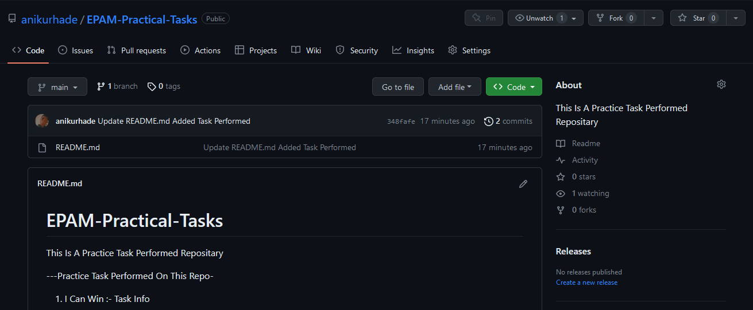

1. Create a file called song.txt and put there half the text of your favorite song.

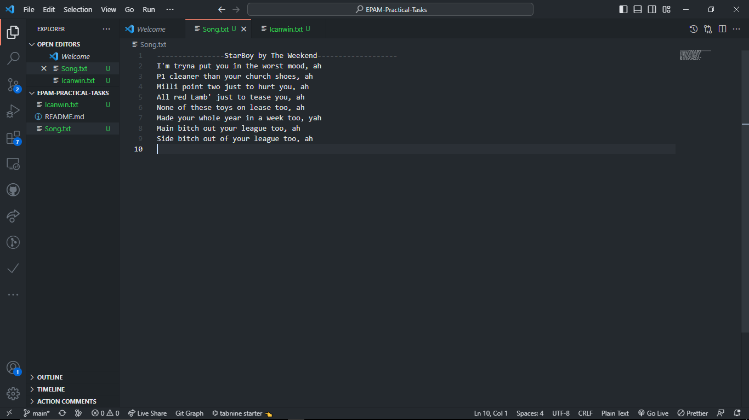

1. Make a commit called "add first half of my favorite song" and send it to the server.

Git Bash About Sending The First Half Of Song On Github repo



1. Make sure github has a song.txt file with the lyrics.

Song.txt On Github Repositary


1. 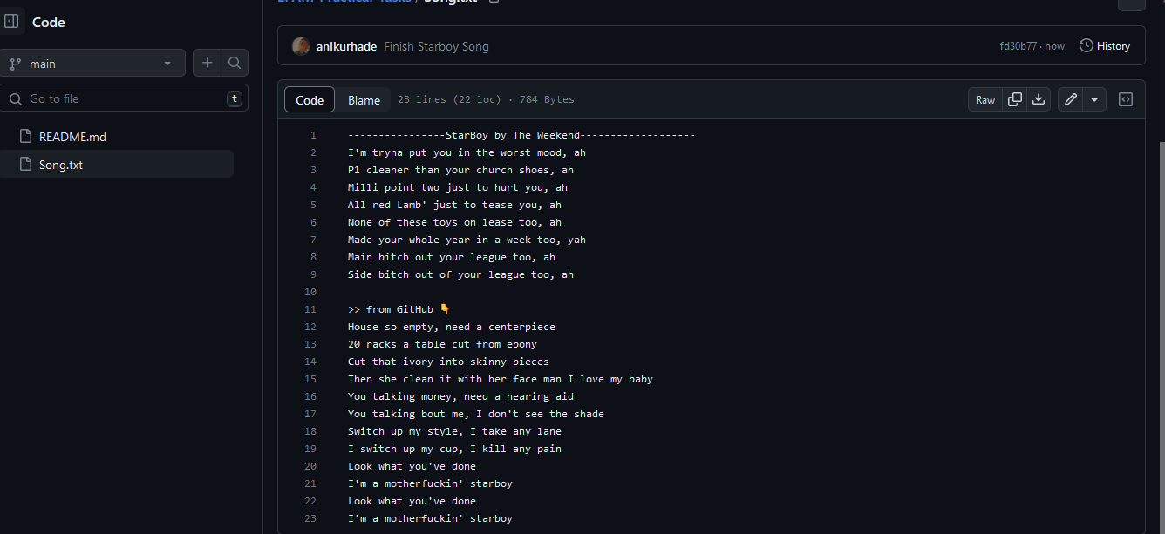Using the github's web interface, add the second half of the lyrics and make a commit with the name "finish my song".
2. Make a pull in the local repository and make sure that the commit you created on github is pulled up and you have all the lyrics.

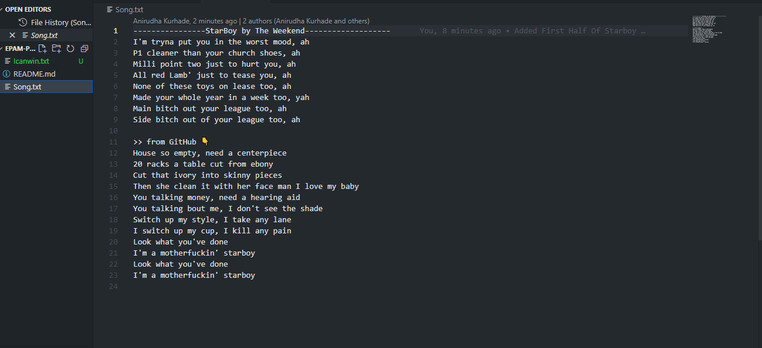

* Task 2

1. 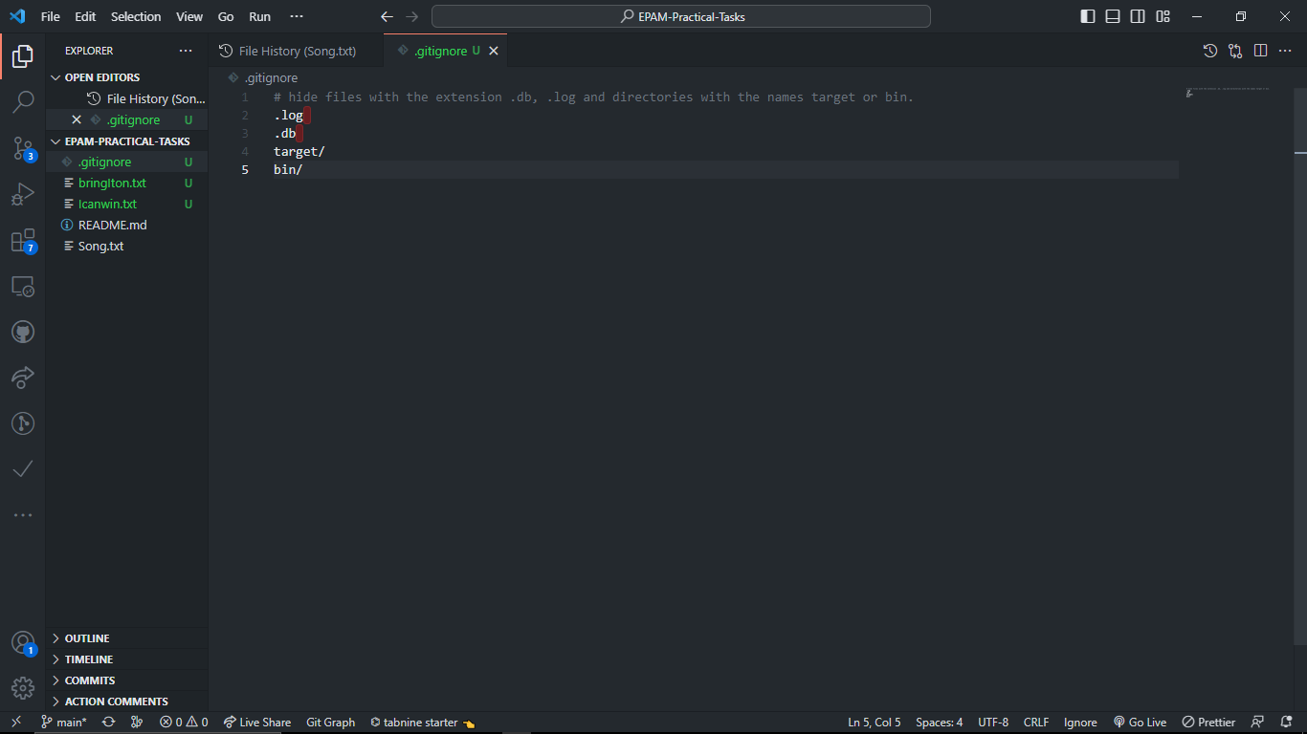Add a .gitignore file to the project and configure it to hide files with the extension **.db, .log** and directories with the names **target** or **bin**.
2. A black screen with yellow text

   Description automatically generated with low confidenceCreate a feature branch and add two commits to it

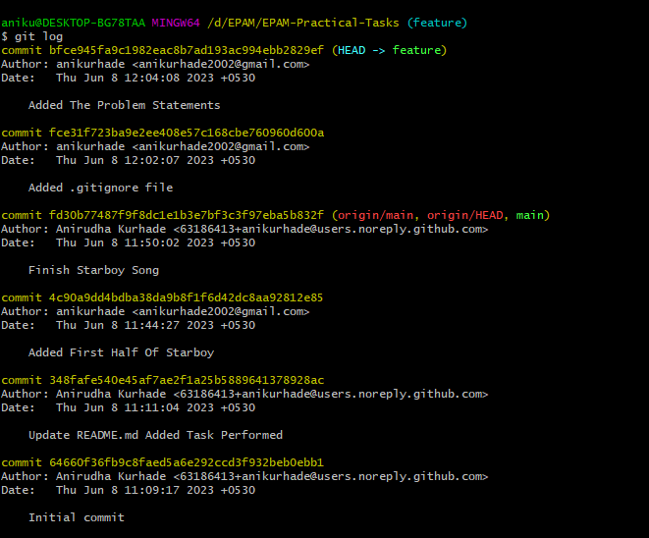

3. Merge the feature branch in master

4. Return to feature and create the arrows.txt file with the following contents:

The ship glides gently on the waves  
As day turns into night

Make a commit.

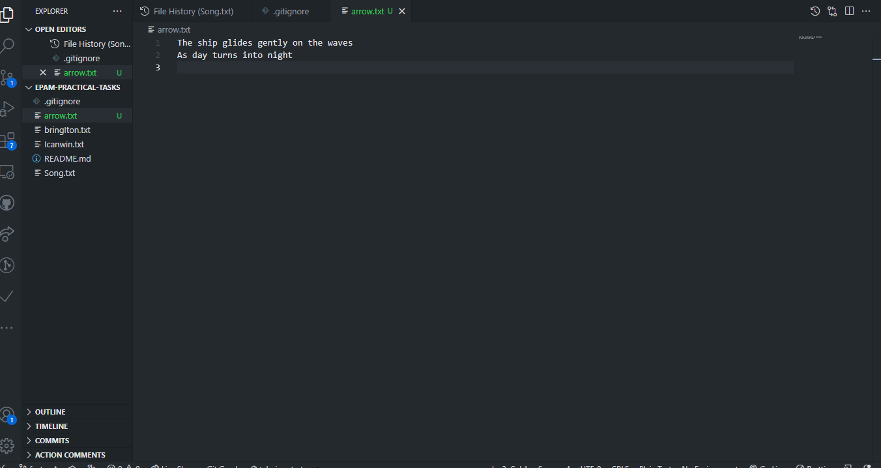

5. Go to master. Create the arrows.txt file there and add the following text:

One thousand burning arrows

Fill the starlit sky

Make a commit.

6. Merge feature in master resolving the conflict: save all 4 lines in arrows.txt file in the order they were added in steps 4 and 5.

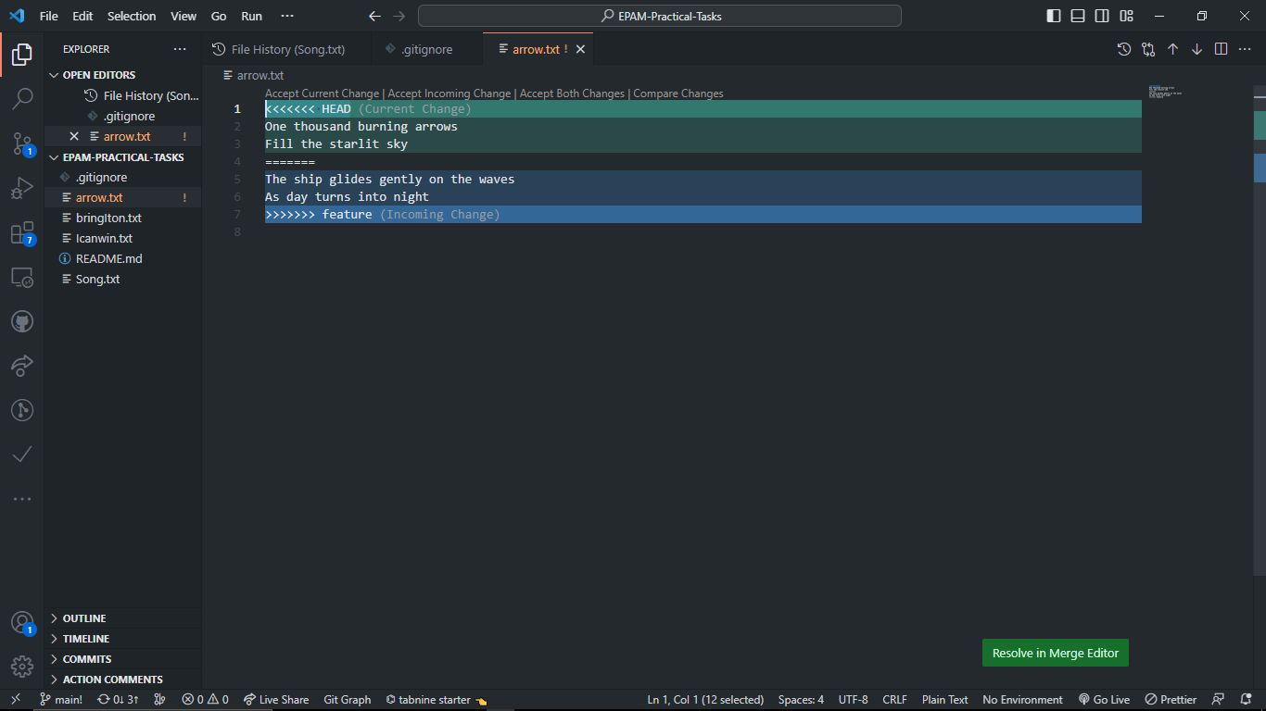

* Task 3

This task is performed after the previous one (Bring It On).

* 1. Create a storm branch and add a commit to the storm.txt file:

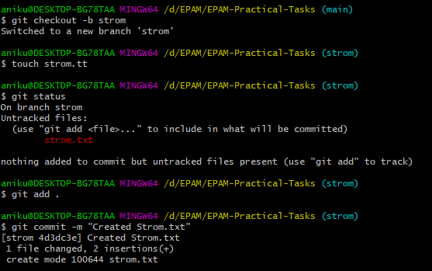Twenty ships with Norsemen braves  
Riding the northern wind

* 1. Add 2 more lines to storm.txt and make another commit:

They left their shores at early dawn  
As a red sun was rising in the east

* 1. Return to master and create the pursuit.txt file with the text below:

The warming sun returns again  
And melts away the snow  
The sea is freed from icy chains  
Winter is letting go

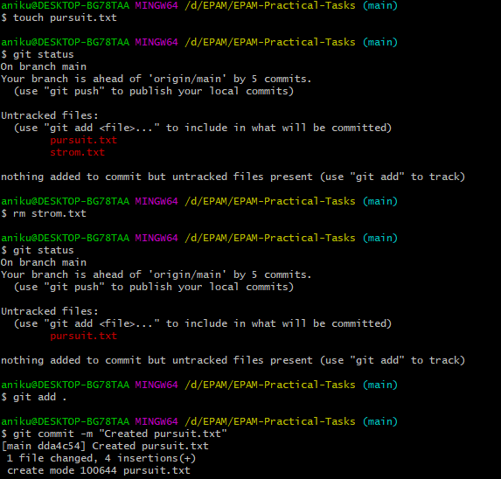Make a commit.

* 1. A screen shot of a computer

     Description automatically generated with medium confidenceMark the commit with session1 tag and go to the storm branch.

gitk of Main branch👆

gitk of storm branch👆

* 1. Rebase the storm branch so that it contains the last commit from the master.

gitk of storm branch(After Rebase)👆

* Task 4
* Task 5